**COMP30022 Sprint 1 Checklist**

Team Name:

Supervisor:

Process

* Communication tool up to date?

The communication tools are up to date. As a team, we continue to communicate through zoom for weekly stand-up meetings, assigning tasks and taking responsibility for artefacts. Trello is still used to communicate to the team each member’s task and responsibilities, and WeChat has become our primary communication tool for front-end/ back-end team communication.

* Team documents up to date, including meeting minutes, task assignments?

The team documents are up to date. Week 6 and Week 9 Meeting minutes can be found in each week’s folder provided in the GitHub repository (‘./docs/Week6/Meeting Minutes’ & ‘./docs/Week9/Meeting Minutes’)

Task assignments can be seen in the Trello screenshot below.

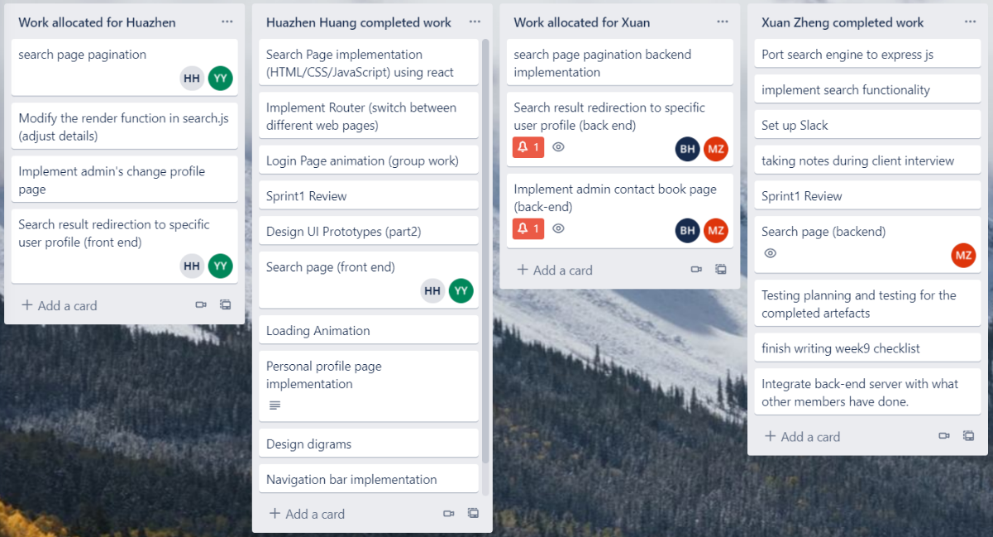

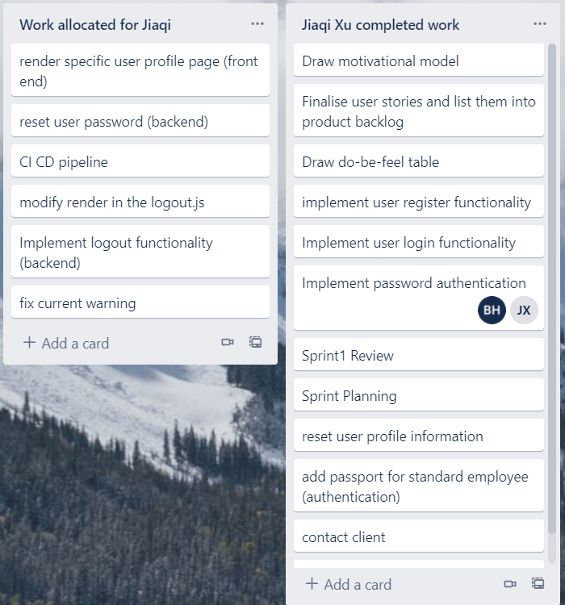

* Are all team members contributing as equally as feasible? Elaborate as needed.

Except Xuan Zheng, other team mates are activate throughout all sprints and contribute equally. Yunqing Yu and Huazhen Huang are in charge of Frontend. Bowei Huang and Jiaqi Xu are in charge of Backend. While Xuan Zheng often has no connection with us and does not reply our message on time.

* Have you done a sprint retrospective?

A sprint retrospective has been completed. It is included in the GitHub repository at ‘./docs/Week9/Sprint retrospective’.

Artefacts

Have requirements been updated?

Requirements for this sprint has been updated during two sprints. After sprint 1, the client required to separate our initial target user into standard user and admin. And therefore, the product backlog and the motivational model is modified. We add the admin and standard user entry at the home page. And more functionalities for admin only is added in product backlog.

Also, the epics of “Contact Management” is decided to be deleted according to our current progress.

klk;kjklj

Have design artefacts been modified?

The initial flow diagram has been discarded. New UI for admin home page is working in progress. And there are new design diagrams (Broad Planning, Domain Model, Use Case) drawn which are sit in Git repository

<https://github.com/Karliex/Team_045-IT-project/tree/main/docs/Week%209>

klk;kjklj

What tasks were completed in the sprint?

The completed artefacts can be seen in the Trello images. In detail, completed tasks in sprint0, sprint1 and sprint 2 are listed in ‘./docs/week9/sprint review+ planning’ in Git repository

Do you have coding standards? If so, give link.

Coding standards have been checked by Huazhen, and summarized into a document in Git repository’s Week 9 folder.

<https://github.com/Karliex/Team_045-IT-project/tree/main/docs/Week%209>

Do you have a testing plan? If so, give link.

A rubric for testing each component and part of the currently designed website can be found in the GitHub repository.

Do you have a deployment pipeline? If so, elaborate on your tool and status of deployment.

We use Heroku to deploy our application. It is connected with our git repository and will automatically update deployment every time a new commitment pushed to the repository. But there are still bugs when opening the application with Heroku’s URL.

**Link for GitHub repository:**

https://github.com/Karliex/Team_045-IT-project

The files for week 9 sprint are located at:

https://github.com/Karliex/Team_045-IT-project/tree/main/docs/Week%209